Ideation Phase
Brainstorm & Idea Prioritization

Date | 27.09.2026
Team ID | 6ab1d5c192b876d9664095f0
Project Name | Streamlining IT procurement: Automating stardard laptop orders with flow designer
Maximum Marks | 4 Marks

Brainstorm & Idea Prioritization :
This report documents the brainstorming process used to automate laptop request task creation using flow designer

Step-1: Team Gathering, Collaboration and Select the Problem Statement
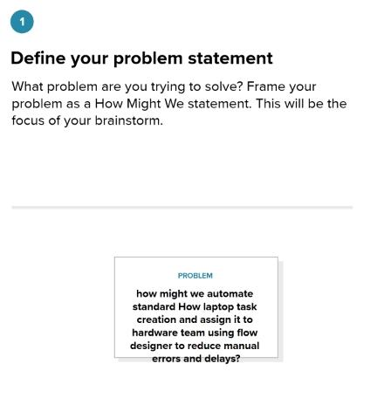

Step-2: Brainstorm, Idea Listing and Grouping
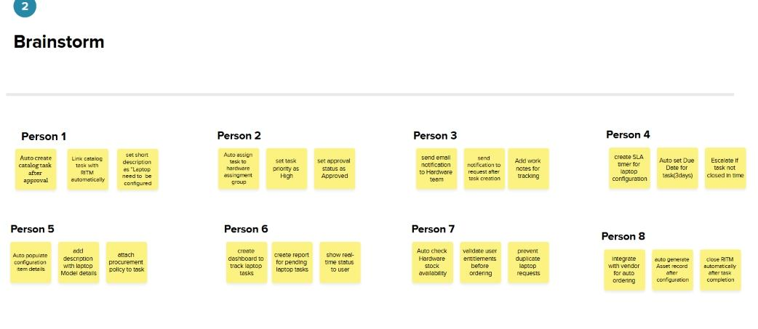

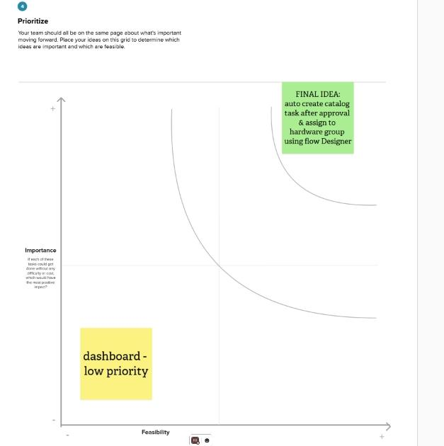
Step-3: Idea Prioritization:

